**IBM Cloud Registration**

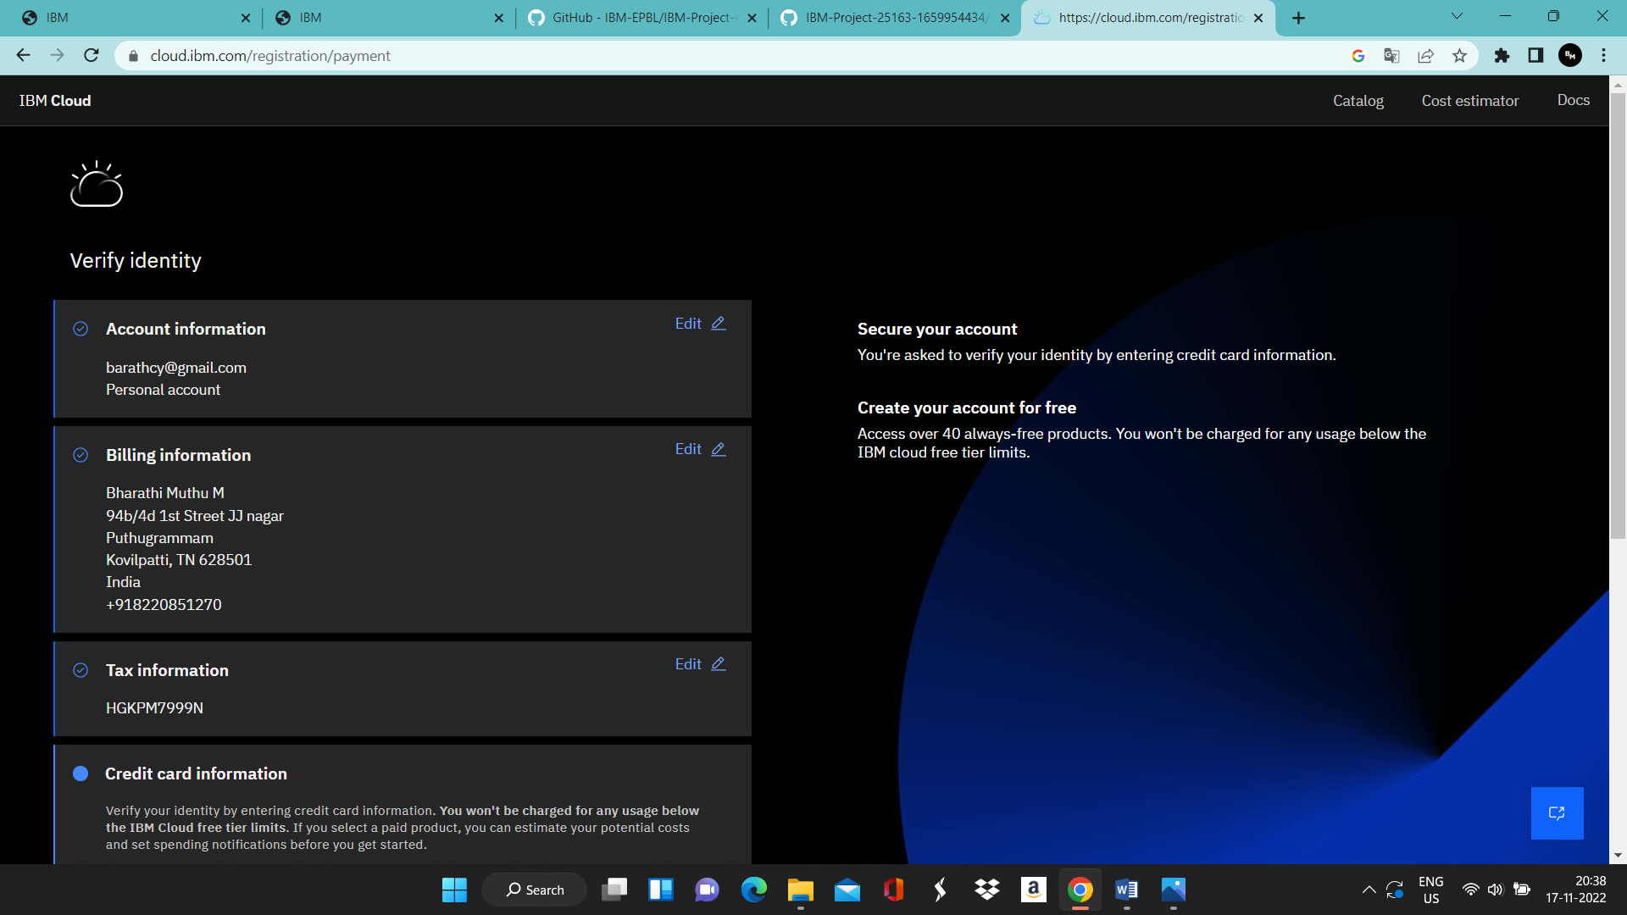

**Train image Classification Model**